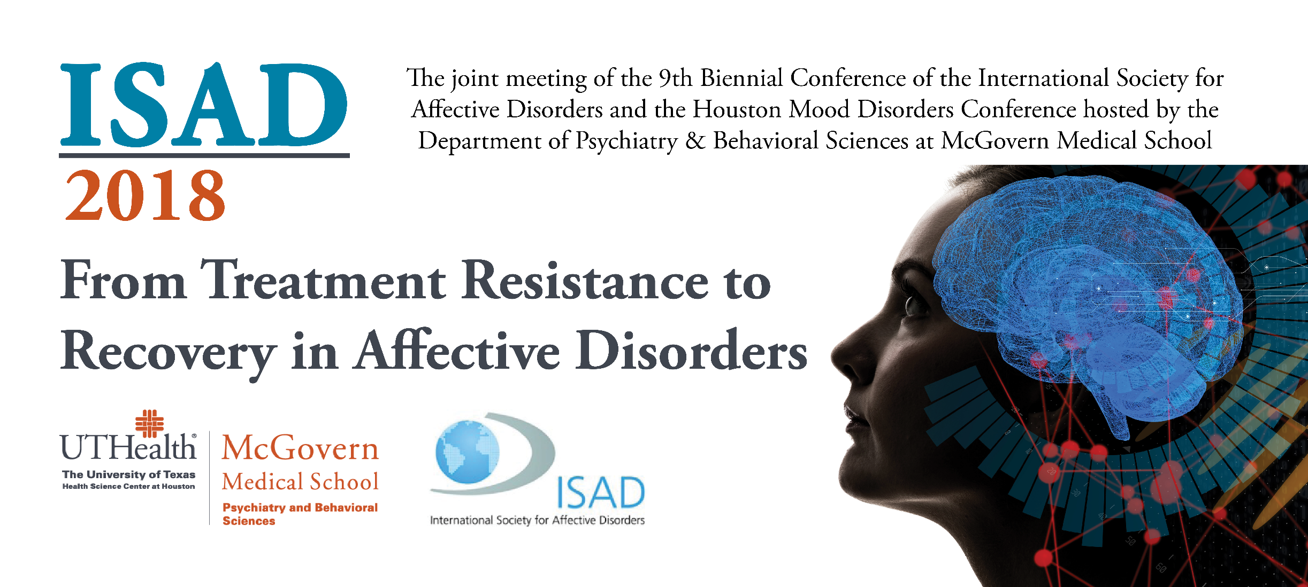
FIRST ANNOUNCEMENT AND CALL FOR ABSTRACTS

9th Biennial Conference of the International Society for Affective Disorders in partnership with 2018 Houston Mood Disorders Conference
20th to 22nd September 2018, Houston, Texas
Main theme: From Treatment Resistance to Recovery in Affective Disorders

The primary aim of ISAD’s conferences is to promote research into the affective disorders through all relevant scientific disciplines, including neuroscience, psychopharmacology, genetics and the social and behavioural sciences. Inter-disciplinary research approaches are particularly highly valued by the society.

ISAD also aims to promote networking, exchange of ideas and experiences, and advance awareness of the consequence of mental health to global health and human development.

ISAD has a reputation for providing high level, well-balanced scientific programmes. The format for conference is a series of parallel symposia held over the 3 days of the conference. There is a keynote plenary lecture every day. There is also a strong emphasis on free oral communications and posters.

Instructions for Parallel Symposia Submissions
- Symposium Title
- Abstract – description of the focus of the symposium and topics that will be addressed (500 word limit)
- Four suggested speakers
- Tentative titles for each speaker
- Email addresses & affiliation for each speaker
- Confirm that all speakers have agreed to participate

Parallel Symposia are 90 minutes in length.
It is compulsory to have three (3) speakers, and 1 chair/moderator who can also double as speaker.
Each Parallel Symposium is a moderately formal 1.5 hour session. Parallel Symposia should be structured to incorporate audience member discussion, e.g. introduction 5 minutes, three presentations of 20 minutes followed by 5 minutes discussion, and 10 minutes for conclusion/final discussion.
It is the responsibility of the chair/moderator to keep the schedule approved by the Program Committee.
Presentations are solely education based. The use of any advertising, trade names, or product-group message association is prohibited; this rule will be strictly enforced.
Parallel Symposia presenters' AND ALL co-authors' disclosures must appear on the first slide of the presentation. Slides will be reviewed in the speaker ready room to ensure compliance.
Once a Parallel Symposium Session is accepted, speaker changes are NOT allowed unless approved by the Program Committee Chair.
Commercial logos (e.g. Company) are not permitted to appear on meeting materials, including presentation slides.
Speakers who have their Symposia Session accepted will be eligible for a reduced registration fee. Regrettably, no financial assistance can be provided for travel or other expenses. Please note that a chair can also double as a speaker, but that chairs who are not speaking in the session are not eligible for the reduced registration fee.

ISAD would like to invite symposium proposals from the membership that emphasize integrative approaches to:
- Causation
- Primary and secondary prevention
- Treatment

Abstracts may be submitted in any of the following topics:

• Diagnosis / Classification
• Epidemiology
• Comorbidity between mood disorders and other psychiatric disorders, e.g.
psychotic disorders, anxiety disorders, substance use disorders or personality disorders
• Comorbidity between mood disorders and somatic disorders
• Prodromes / Early recognition
• Staging
• Suicide
• Mood disorders in children and adolescents
• Mood disorders in the elderly
• Pregnancy / Childbirth
• Gender / Women
• Disability / Cognition
• Genetics / Epigenetics / Proteomics
• Brain structure and brain function
• Molecular / Cellular Markers and Models
• Treatment guidelines
• Pharmacological / Somatic treatments
• Psychological treatments
• Psychoeducation / Self-management
• Rehabilitation
• Novel treatments
• Service management / Integration of treatments
• Service delivery / Psychiatric nursing
• Population health / economics
• Cultural differences and its consequences
• Fighting stigma
• Advocacy / Patient organisations
• Other (specify): ………………………… ​

Please complete the requested information on the form provided below. This form can be down loaded from the McGovern Medical School website as a word document at: https://med.uth.edu/psychiatry/education/cme/isad-2018
Submissions should be made to: ISAD2018@uth.tmc.edu

9th International Biennial Conference
September 2018
Houston, Texas, USA

Symposium Proposal

Symposium Title:

---------------------------------------------------------------------------------------------------

Symposium Chair:

----------------------------------------------------------------------------------------------------

Details of individual presentations and speakers:

Presentation Title | Suggested Speaker | Email Address | Affiliation and/or Institution | Speaker Agreed?  Y/N?

Abstract:

Please limit your abstract to 500 words.

Proposer details:
Name:
Address:

Tel:
Fax:
Email:

Deadline for submissions is: Wednesday, April 18, 2018

This activity has been approved for AME PRA Category 1 Credit™.

